**Student Information System (SIS)**

**Task 1. Database Design:**

1. Create the database named "SISDB"

Ans) CREATE DATABASE SISDB;

USE SISDB;

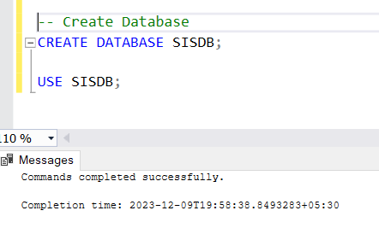

2. Define the schema for the Students, Courses, Enrollments, Teacher, and Payments tables based on the provided schema. Write SQL scripts to create the mentioned tables with appropriate data types, constraints, and relationships.

a. Students b. Courses

c. Enrollments d. Teacher

e. Payments

Ans)

-- Create Students Table

CREATE TABLE Students (

student_id INT PRIMARY KEY,

first_name VARCHAR(255),

last_name VARCHAR(255),

date_of_birth DATE,

email VARCHAR(255),

phone_number VARCHAR(15)

);

-- Create Teacher Table

CREATE TABLE Teacher (

teacher_id INT PRIMARY KEY,

first_name VARCHAR(255),

last_name VARCHAR(255),

email VARCHAR(255)

);

-- Create Courses Table

CREATE TABLE Courses (

course_id INT PRIMARY KEY,

course_name VARCHAR(255),

credits INT,

teacher_id INT,

FOREIGN KEY (teacher_id) REFERENCES Teacher(teacher_id)

);

-- Create Enrollments Table

CREATE TABLE Enrollments (

enrollment_id INT PRIMARY KEY,

student_id INT,

course_id INT,

enrollment_date DATE,

FOREIGN KEY (student_id) REFERENCES Students(student_id),

FOREIGN KEY (course_id) REFERENCES Courses(course_id)

);

-- Create Payments Table

CREATE TABLE Payments (

payment_id INT PRIMARY KEY,

student_id INT,

amount DECIMAL(10, 2),

payment_date DATE,

FOREIGN KEY (student_id) REFERENCES Students(student_id)

);

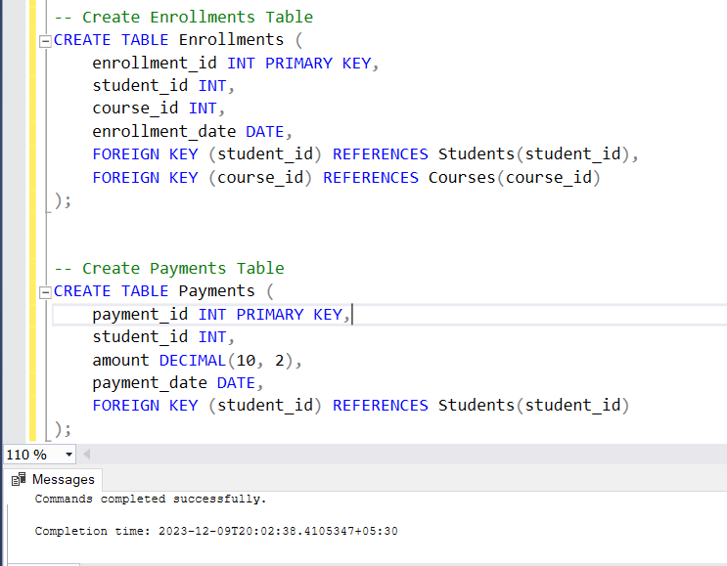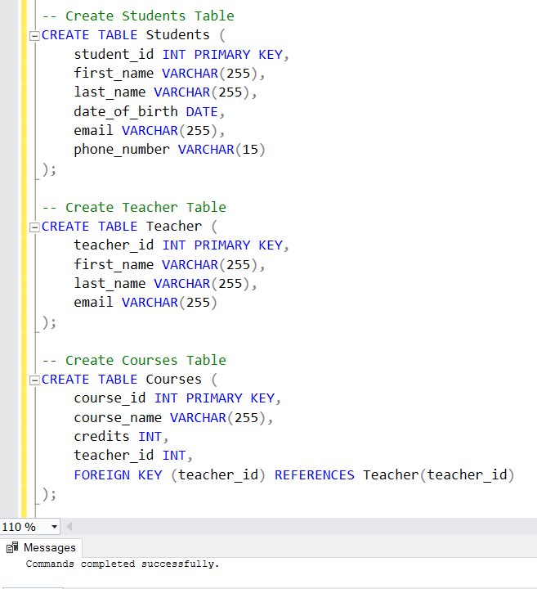

1. Create an ERD (Entity Relationship Diagram) for the database.

Ans)

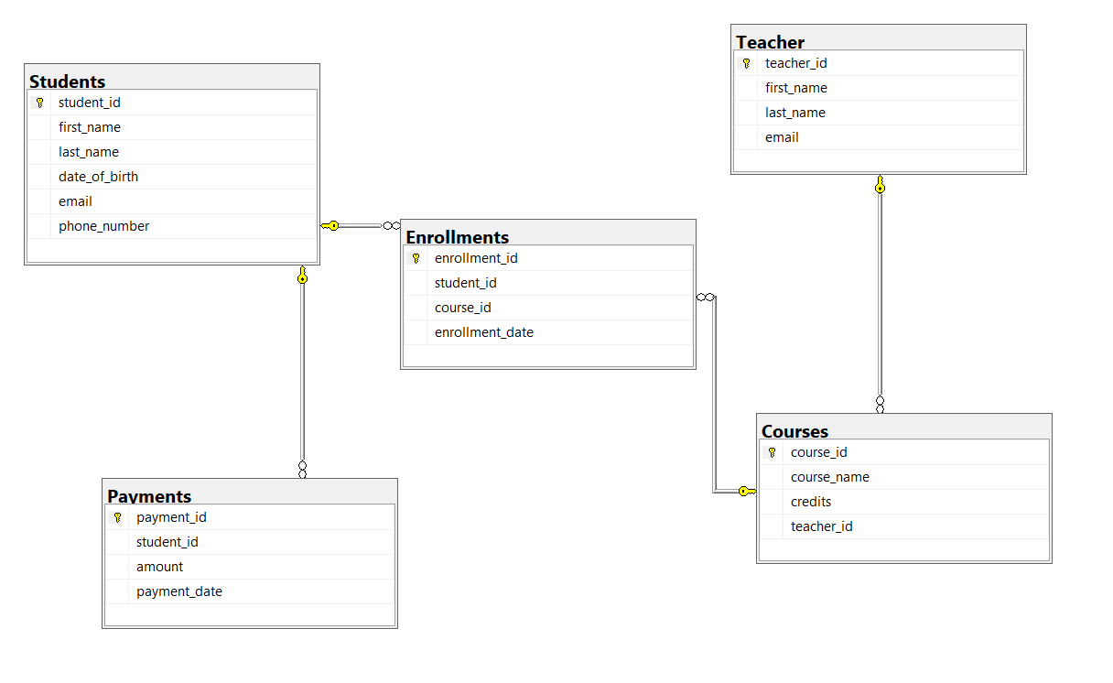

1. Create appropriate Primary Key and Foreign Key constraints for referential integrity.

Ans) Already did in question 2.

5. Insert at least 10 sample records into each of the following tables. i. Students

ii. Courses

iii. Enrollments iv. Teacher

v. Payments

Ans)

-- Insert 10 Sample Records into Students Table

INSERT INTO Students VALUES

(1, 'Alice', 'Johnson', '1995-05-10', 'alice.j@email.com', '123-456-7890'),

(2, 'Bob', 'Smith', '1993-08-22', 'bob.smith@email.com', '987-654-3210'),

(3, 'Charlie', 'Brown', '1998-03-18', 'charlie.b@email.com', '555-123-7890'),

(4, 'Diana', 'Miller', '1994-11-28', 'diana.m@email.com', '789-456-0123'),

(5, 'Eva', 'Williams', '1996-06-15', 'eva.w@email.com', '456-789-0123'),

(6, 'Frank', 'Davis', '1997-09-30', 'frank.d@email.com', '321-987-6540'),

(7, 'Grace', 'Thomas', '1992-12-05', 'grace.t@email.com', '555-555-5555'),

(8, 'Henry', 'Clark', '1990-04-20', 'henry.c@email.com', '111-222-3333'),

(9, 'Isabel', 'Wilson', '1999-01-25', 'isabel.w@email.com', '999-888-7777'),

(10, 'Jack', 'Moore', '1991-07-12', 'jack.m@email.com', '333-444-5555');

-- Insert 10 Sample Records into Teacher Table

INSERT INTO Teacher VALUES

(1, 'Dr.', 'Brown', 'dr.brown@email.com'),

(2, 'Prof.', 'Williams', 'prof.williams@email.com'),

(3, 'Prof.', 'Davis', 'prof.davis@email.com'),

(4, 'Dr.', 'Johnson', 'dr.johnson@email.com'),

(5, 'Prof.', 'Taylor', 'prof.taylor@email.com'),

(6, 'Dr.', 'Smith', 'dr.smith@email.com'),

(7, 'Prof.', 'Miller', 'prof.miller@email.com'),

(8, 'Dr.', 'Moore', 'dr.moore@email.com'),

(9, 'Prof.', 'Clark', 'prof.clark@email.com'),

(10, 'Dr.', 'Wilson', 'dr.wilson@email.com');

-- Insert 10 Sample Records into Courses Table

INSERT INTO Courses VALUES

(101, 'Mathematics 101', 4, 3),

(102, 'Introduction to Physics', 3, 2),

(103, 'History of Art', 3, 4),

(104, 'Chemistry Basics', 4, 1),

(105, 'English Literature', 3, 3),

(106, 'Computer Programming', 4, 1),

(107, 'Statistics', 3, 2),

(108, 'Psychology 101', 3, 4),

(109, 'Economics Fundamentals', 4, 2),

(110, 'Environmental Science', 4, 3);

-- Insert 10 Sample Records into Enrollments Table

INSERT INTO Enrollments VALUES

(1, 1, 101, '2023-01-15'),

(2, 2, 102, '2023-01-20'),

(3, 3, 103, '2023-02-10'),

(4, 4, 104, '2023-02-15'),

(5, 5, 105, '2023-03-01'),

(6, 6, 106, '2023-03-05'),

(7, 7, 107, '2023-03-20'),

(8, 8, 108, '2023-04-01'),

(9, 9, 109, '2023-04-15'),

(10, 10, 110, '2023-05-01');

-- Insert 10 Sample Records into Payments Table

INSERT INTO Payments VALUES

(1, 1, 250.00, '2023-02-01'),

(2, 2, 300.00, '2023-02-05'),

(3, 3, 150.00, '2023-03-01'),

(4, 4, 400.00, '2023-03-05'),

(5, 5, 200.00, '2023-04-01'),

(6, 6, 350.00, '2023-04-05'),

(7, 7, 180.00, '2023-05-01'),

(8, 8, 420.00, '2023-05-05'),

(9, 9, 300.00, '2023-06-01'),

(10, 10, 280.00, '2023-06-05');

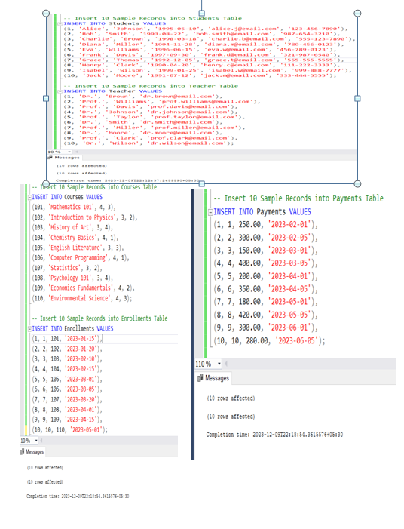

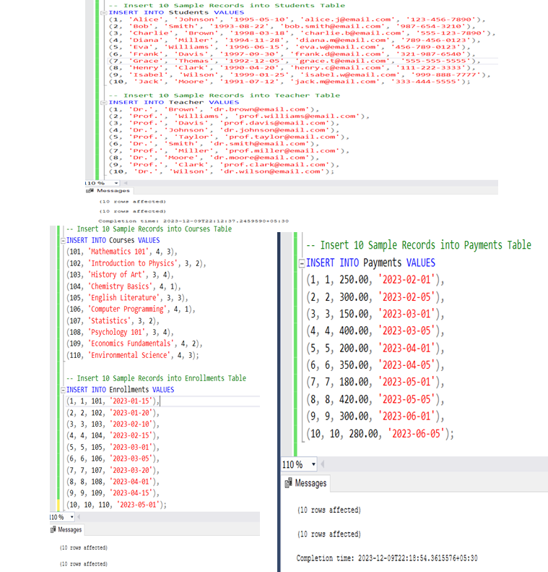

**Tasks 2: Select, Where, Between, AND, LIKE:**

1. Write an SQL query to insert a new student into the "Students" table with the following details:

a. First Name: John

b. Last Name: Doe

c. Date of Birth: 1995-08-15

d. Email: john.doe@example.com e. Phone Number: 1234567890

Ans) INSERT INTO Students (student_id, first_name, last_name, date_of_birth, email, phone_number)

VALUES (11, 'John', 'Doe', '1995-08-15', 'john.doe@example.com', '1234567890');

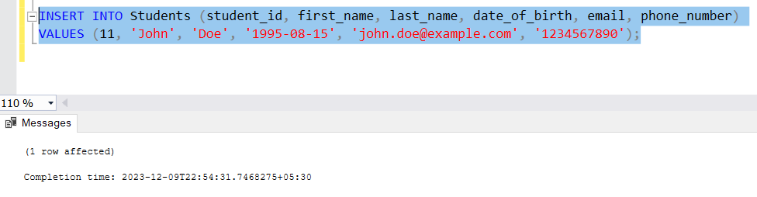

2. Write an SQL query to enroll a student in a course. Choose an existing student and course and

insert a record into the "Enrollments" table with the enrollment date.

Ans) INSERT INTO Enrollments (enrollment_id, student_id, course_id, enrollment_date)

VALUES (11,1, 101, '2023-07-01');

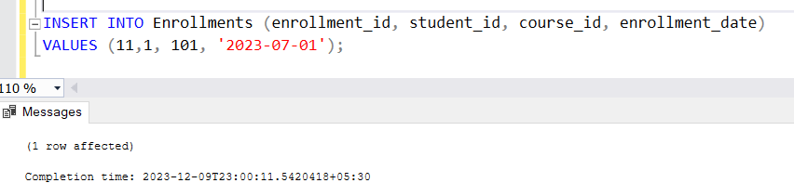

1. Update the email address of a specific teacher in the "Teacher" table. Choose any teacher and modify their email address.

Ans) UPDATE Teacher SET email = 'new.email@example.com'

WHERE teacher_id = 1;

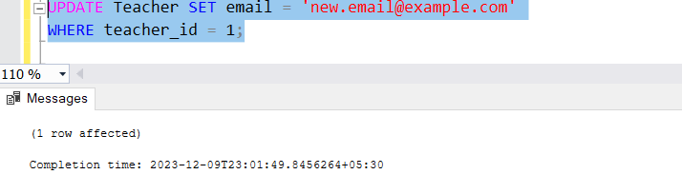

1. Write an SQL query to delete a specific enrollment record from the "Enrollments" table. Select an enrollment record based on the student and course.

Ans) DELETE FROM Enrollments WHERE enrollment_id = 1;

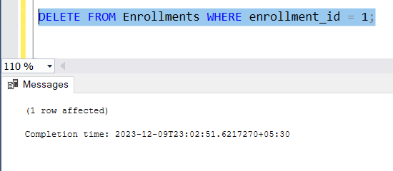

1. Update the "Courses" table to assign a specific teacher to a course. Choose any course and teacher from the respective tables.

Ans) UPDATE Courses SET teacher_id = 2 WHERE course_id = 101;

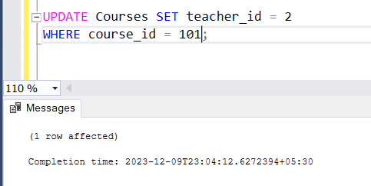

1. Delete a specific student from the "Students" table and remove all their enrollment records from the "Enrollments" table. Be sure to maintain referential integrity.

Ans) DELETE FROM Enrollments WHERE student_id = 1;

DELETE FROM Payments WHERE student_id = 1;

DELETE FROM Students WHERE student_id = 1;

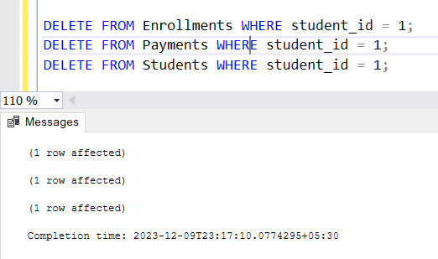

7. Update the payment amount for a specific payment record in the "Payments" table. Choose any

payment record and modify the payment amount.

Ans) UPDATE Payments SET amount = 650.00 WHERE payment_id = 5;

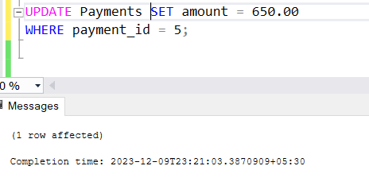

**Task 3. Aggregate functions, Having, Order By, GroupBy and Joins:**

1. Write an SQL query to calculate the total payments made by a specific student. You will need to join the "Payments" table with the "Students" table based on the student's ID.

Ans) SELECT s.student_id, s.first_name, s.last_name, SUM(p.amount) AS total_payments

FROM Students s JOIN Payments p ON s.student_id = p.student_id

Group By s.student_id, s.first_name, s.last_name

Having s.student_id = 5;

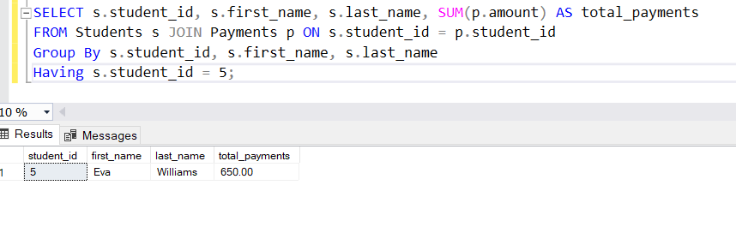

1. Write an SQL query to retrieve a list of courses along with the count of students enrolled in each course. Use a JOIN operation between the "Courses" table and the "Enrollments" table.

Ans) SELECT c.course_id, c.course_name, COUNT(e.student_id) AS enrolled_students_count

FROM Courses c LEFT JOIN Enrollments e ON c.course_id = e.course_id

GROUP BY c.course_id, c.course_name;

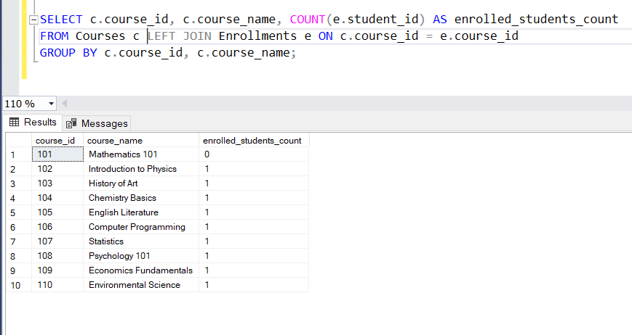

1. Write an SQL query to find the names of students who have not enrolled in any course. Use a LEFT JOIN between the "Students" table and the "Enrollments" table to identify students without enrollments.

Ans) SELECT s.first_name, s.last_name

FROM Students s LEFT JOIN Enrollments e ON s.student_id = e.student_id

WHERE e.student_id IS NULL;

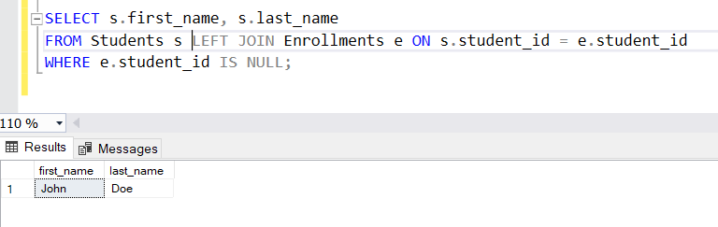

1. Write an SQL query to retrieve the first name, last name of students, and the names of the courses they are enrolled in. Use JOIN operations between the "Students" table and the "Enrollments" and "Courses" tables.

Ans) SELECT s.first_name, s.last_name, c.course_name

FROM Students s

JOIN Enrollments e ON s.student_id = e.student_id

JOIN Courses c ON e.course_id = c.course_id;

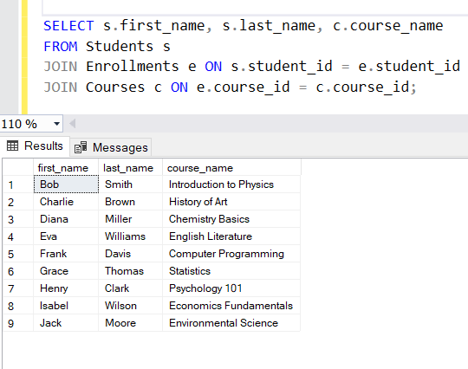

5. Create a query to list the names of teachers and the courses they are assigned to. Join the

"Teacher" table with the "Courses" table.

Ans) SELECT t.first_name, t.last_name, c.course_name

FROM Teacher t

JOIN Courses c ON t.teacher_id = c.teacher_id;

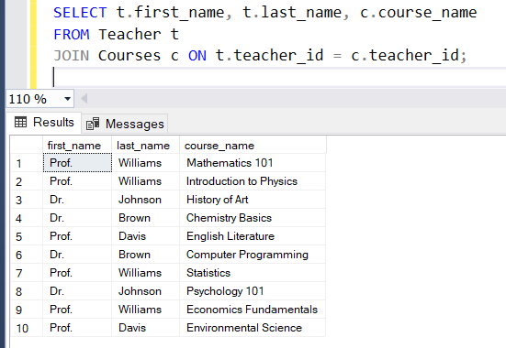

6. Retrieve a list of students and their enrollment dates for a specific course. You'll need to join the

"Students" table with the "Enrollments" and "Courses" tables.

Ans) SELECT s.first_name, s.last_name, e.enrollment_date

FROM Students s

JOIN Enrollments e ON s.student_id = e.student_id

WHERE e.course_id = 104; -- Specify the desired course_id

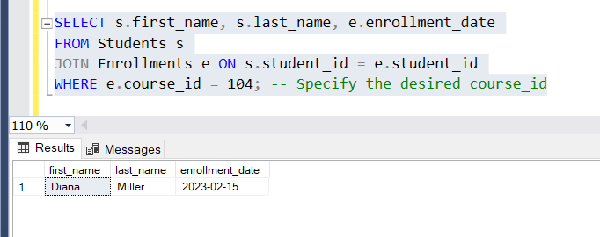

7. Find the names of students who have not made any payments. Use a LEFT JOIN between the

"Students" table and the "Payments" table and filter for students with NULL payment records.

Ans) SELECT s.first_name, s.last_name

FROM Students s

LEFT JOIN Payments p ON s.student_id = p.student_id

WHERE p.student_id IS NULL;

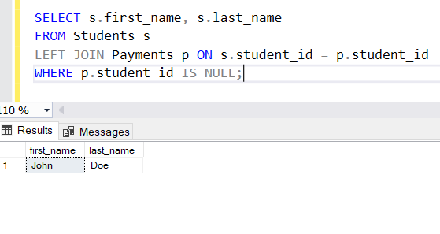

1. Write a query to identify courses that have no enrollments. You'll need to use a LEFT JOIN between the "Courses" table and the "Enrollments" table and filter for courses with NULL enrollment records.

Ans) SELECT c.course_id, c.course_name

FROM Courses c

LEFT JOIN Enrollments e ON c.course_id = e.course_id

WHERE e.course_id IS NULL;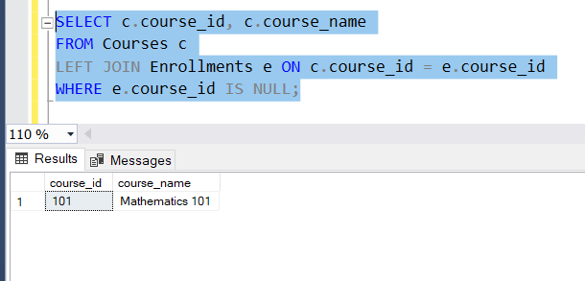

1. Identify students who are enrolled in more than one course. Use a self-join on the "Enrollments" table to find students with multiple enrollment records.

Ans) SELECT s.student_id, s.first_name, s.last_name, COUNT(DISTINCT e1.course_id) AS enrollment_count FROM Students s

JOIN Enrollments e1 ON s.student_id = e1.student_id

JOIN Enrollments e2 ON e1.student_id = e2.student_id AND e1.enrollment_id <> e2.enrollment_id

GROUP BY s.student_id, s.first_name, s.last_name

HAVING COUNT(DISTINCT e1.course_id) > 1;

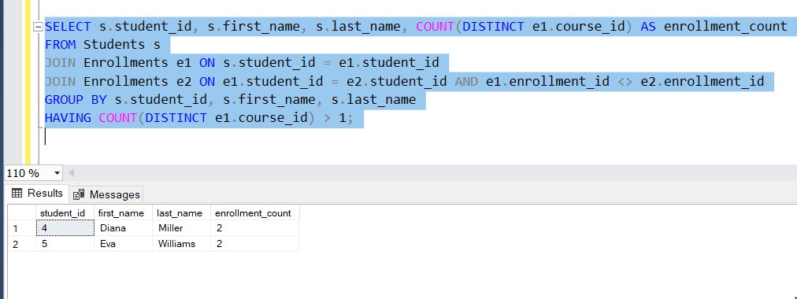

1. Find teachers who are not assigned to any courses. Use a LEFT JOIN between the "Teacher" table and the "Courses" table and filter for teachers with NULL course assignments.

Ans) SELECT t.teacher_id, t.first_name, t.last_name FROM Teacher t

LEFT JOIN Courses c ON t.teacher_id = c.teacher_id

WHERE c.course_id IS NULL;

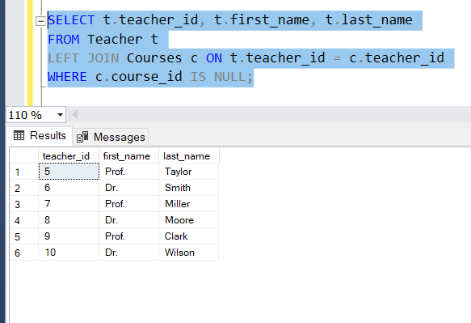

**Task 4. Subquery and its type:**

1. Write an SQL query to calculate the average number of students enrolled in each course. Use aggregate functions and subqueries to achieve this.

Ans) SELECT course_id, AVG(enrollment_count) AS average_students_enrolled

FROM (

SELECT course_id, COUNT(DISTINCT student_id) AS enrollment_count

FROM Enrollments

GROUP BY course_id

) AS course_enrollments

GROUP BY course_id;

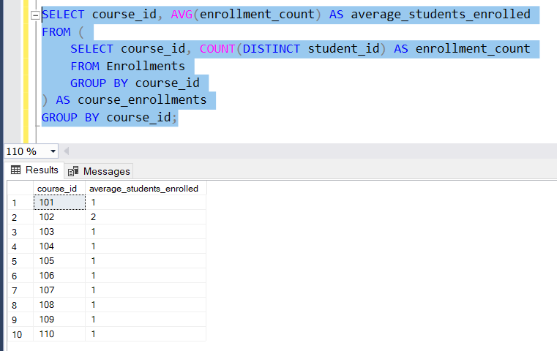

1. Identify the student(s) who made the highest payment. Use a subquery to find the maximum payment amount and then retrieve the student(s) associated with that amount.

Ans) SELECT student_id, first_name, last_name FROM Students

WHERE student_id IN (

SELECT TOP 1 student_id

FROM Payments

ORDER BY amount DESC);

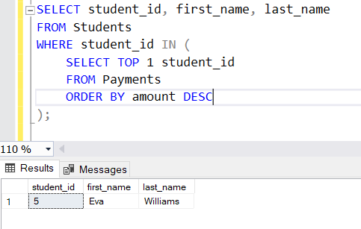

1. Retrieve a list of courses with the highest number of enrollments. Use subqueries to find the course(s) with the maximum enrollment count.

Ans) SELECT course_id, course_name FROM Courses

WHERE course_id IN (

SELECT Top 1 course_id

FROM Enrollments

GROUP BY course_id

ORDER BY COUNT(student_id) DESC);

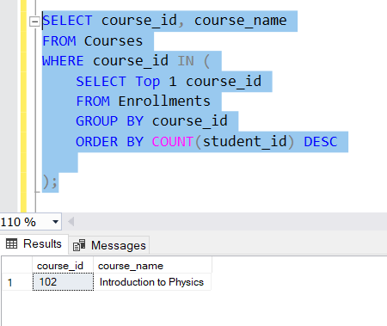

1. Calculate the total payments made to courses taught by each teacher. Use subqueries to sum payments for each teacher's courses.

Ans) SELECT teacher_id, SUM(amount) AS total_payments

FROM(

SELECT T.teacher_id, P.amount FROM Teacher T

JOIN Courses C ON T.teacher_id = C.teacher_id

JOIN Enrollments E ON C.course_id = E.course_id

JOIN Payments P ON E.student_id = p.student_id

) AS teach_payments

GROUP BY teacher_id;

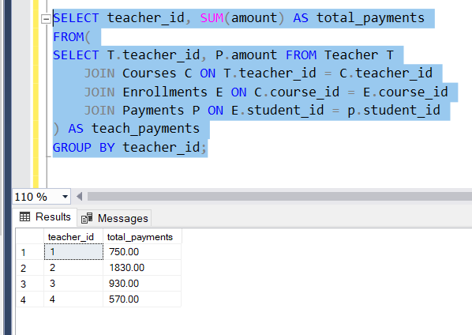

1. Identify students who are enrolled in all available courses. Use subqueries to compare a student's enrollments with the total number of courses.

Ans) SELECT student_id, first_name, last_name

FROM Students

WHERE ( SELECT COUNT(DISTINCT course_id) FROM Courses ) = (

SELECT COUNT(DISTINCT course_id)

FROM Enrollments

WHERE student_id = Students.student_id );

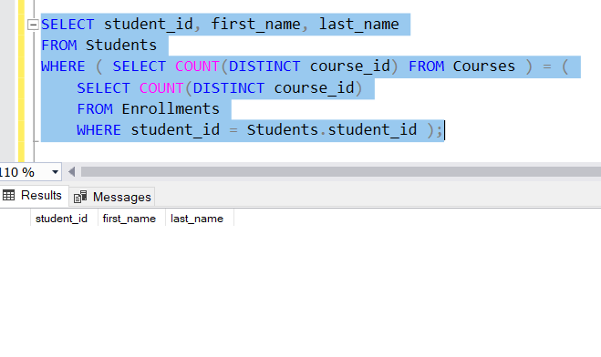

1. Retrieve the names of teachers who have not been assigned to any courses. Use subqueries to find teachers with no course assignments.

Ans) SELECT teacher_id, first_name, last_name

FROM Teacher

WHERE teacher_id NOT IN (

SELECT DISTINCT teacher_id

FROM Courses

WHERE teacher_id IS NOT NULL);

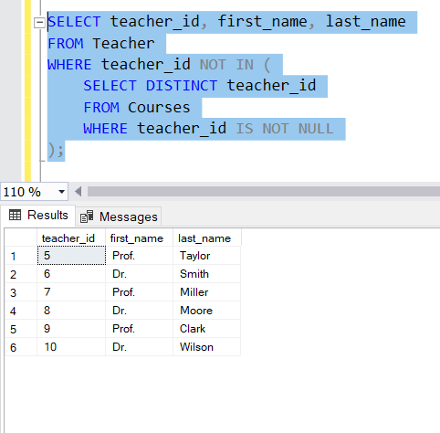

1. Calculate the average age of all students. Use subqueries to calculate the age of each student based on their date of birth.

Ans) SELECT AVG(age) AS average_age

FROM (

SELECT DATEDIFF(YEAR, date_of_birth,GETDATE()) AS age

FROM Students ) AS student_age;

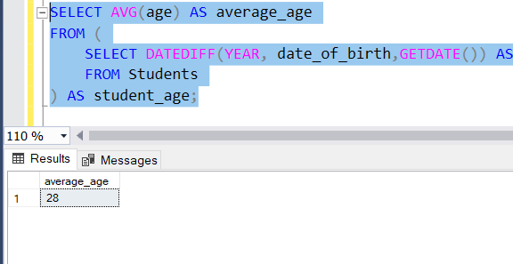

1. Identify courses with no enrollments. Use subqueries to find courses without enrollment records.

Ans) SELECT course_id, course_name

FROM Courses

WHERE course_id NOT IN (

SELECT DISTINCT course_id

FROM Enrollments );

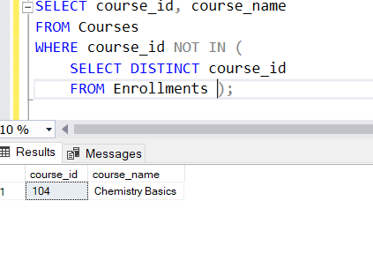

1. Calculate the total payments made by each student for each course they are enrolled in. Use subqueries and aggregate functions to sum payments.

Ans) SELECT e.student_id, s.first_name, s.last_name,e.course_id,c.course_name,

SUM(p.amount) AS total_payments

FROM Enrollments e

JOIN Students s ON e.student_id = s.student_id

JOIN Courses c ON e.course_id = c.course_id

LEFT JOIN Payments p ON e.student_id = p.student_id

GROUP BY e.student_id, s.first_name, s.last_name, e.course_id, c.course_name;

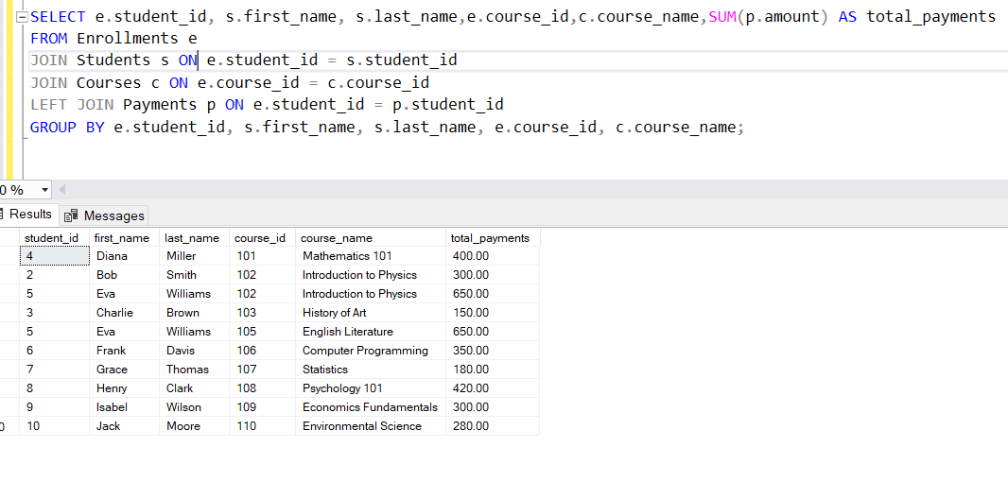

1. Identify students who have made more than one payment. Use subqueries and aggregate functions to count payments per student and filter for those with counts greater than one.

Ans) SELECT student_id, first_name, last_name

FROM Students

WHERE student_id IN (

SELECT student_id

FROM Payments

GROUP BY student_id

HAVING COUNT(payment_id) > 1);

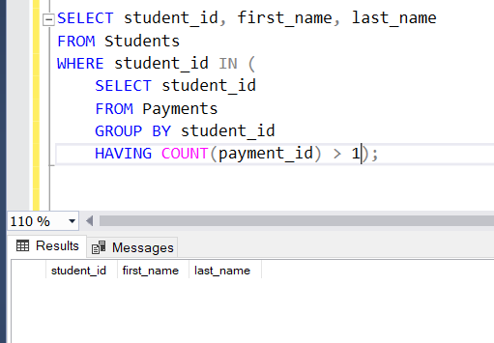

1. Write an SQL query to calculate the total payments made by each student. Join the "Students" table with the "Payments" table and use GROUP BY to calculate the sum of payments for each student.

Ans) SELECT s.student_id, s.first_name, s.last_name, SUM(p.amount) AS total_payments

FROM Students s

LEFT JOIN Payments p ON s.student_id = p.student_id

GROUP BY s.student_id, s.first_name, s.last_name;

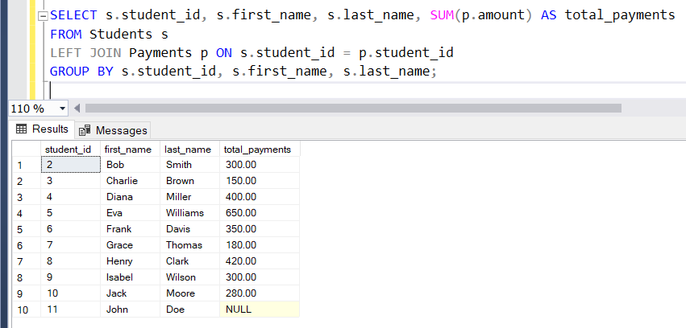

1. Retrieve a list of course names along with the count of students enrolled in each course. Use JOIN operations between the "Courses" table and the "Enrollments" table and GROUP BY to count enrollments.

Ans) SELECT c.course_id, c.course_name, COUNT(e.student_id) AS enrolled_students_count

FROM Courses c

LEFT JOIN Enrollments e ON c.course_id = e.course_id

GROUP BY c.course_id, c.course_name;

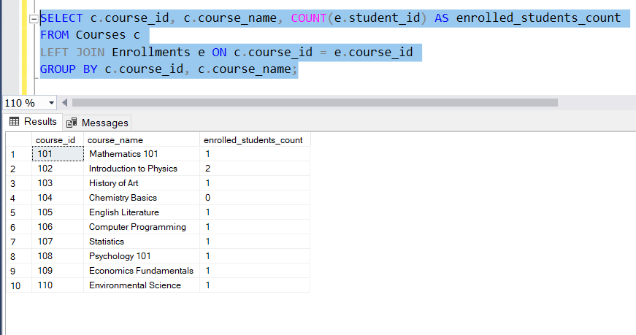

13. Calculate the average payment amount made by students. Use JOIN operations between the

"Students" table and the "Payments" table and GROUP BY to calculate the average.

Ans) SELECT S.student_id, AVG(P.amount) AS average_payment_amount

FROM Payments P

JOIN Students S ON P.student_id=S.student_id

Group BY S.student_id;

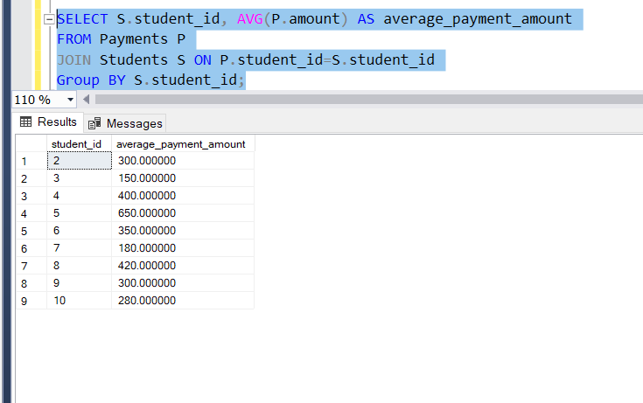

**Student Information System (SIS)**

**Implement OOPs**

A Student Information System (SIS) manages information about students, courses, student enrollments, teachers, and payments. Each student can enroll in multiple courses, each course can have multiple students, each course is taught by a teacher, and students make payments for their courses. Students have attributes such as name, date of birth, email, and phone number. Courses have attributes such as course name, course code, and instructor name. Enrollments track which students are enrolled in which courses. Teachers have attributes such as names and email. Payments track the amount and date of payments made by students.

**Task 1: Define Classes**

Define the following classes based on the domain description:

**Student** class with the following attributes:

• Student ID

• First Name

• Last Name

• Date of Birth

• Email

• Phone Number

**Course** class with the following attributes:

• Course ID

• Course Name

• Course Code

• Instructor Name

**Enrollment** class to represent the relationship between students and courses. It should have attributes:

• Enrollment ID

• Student ID (reference to a Student)

• Course ID (reference to a Course)

• Enrollment Date

**Teacher** class with the following attributes:

• Teacher ID

• First Name

• Last Name

• Email

**Payment** class with the following attributes:

• Payment ID

• Student ID (reference to a Student)

• Amount

• Payment Date

**Task 2: Implement Constructors**

Implement constructors for each class to initialize their attributes. Constructors are special methods that are called when an object of a class is created. They are used to set initial values for the attributes of the class. Below are detailed instructions on how to implement constructors for each class in your Student Information System (SIS) assignment:

**Student Class Constructor**

In the Student class, you need to create a constructor that initializes the attributes of a student when an instance of the Student class is created

**SIS Class Constructor**

If you have a class that represents the Student Information System itself (e.g., SIS class), you may also implement a constructor for it. This constructor can be used to set up any initial configuration for the SIS.

Repeat the above process for each class Course, Enrollment, Teacher, Payment by defining constructors that initialize their respective attributes.

**Task 3: Implement Methods**

Implement methods in your classes to perform various operations related to the Student Information System (SIS). These methods will allow you to interact with and manipulate data within your system. Below are detailed instructions on how to implement methods in each class:

Implement the following methods in the appropriate classes:

**Student Class:**

• EnrollInCourse(course: Course): Enrolls the student in a course.

• UpdateStudentInfo(firstName: string, lastName: string, dateOfBirth: DateTime, email: string, phoneNumber: string): Updates the student's information.

• MakePayment(amount: decimal, paymentDate: DateTime): Records a payment made by the student.

• DisplayStudentInfo(): Displays detailed information about the student.

• GetEnrolledCourses(): Retrieves a list of courses in which the student is enrolled.

• GetPaymentHistory(): Retrieves a list of payment records for the student.

**Course Class:**

• AssignTeacher(teacher: Teacher): Assigns a teacher to the course.

• UpdateCourseInfo(courseCode: string, courseName: string, instructor: string): Updates course information.

• DisplayCourseInfo(): Displays detailed information about the course.

• GetEnrollments(): Retrieves a list of student enrollments for the course.

• GetTeacher(): Retrieves the assigned teacher for the course.

**Enrollment Class:**

• GetStudent(): Retrieves the student associated with the enrollment.

• GetCourse(): Retrieves the course associated with the enrollment.

**Teacher Class:**

• UpdateTeacherInfo(name: string, email: string, expertise: string): Updates teacher information.

• DisplayTeacherInfo(): Displays detailed information about the teacher.

• GetAssignedCourses(): Retrieves a list of courses assigned to the teacher.

**Payment Class:**

• GetStudent(): Retrieves the student associated with the payment.

• GetPaymentAmount(): Retrieves the payment amount.

• GetPaymentDate(): Retrieves the payment date.

**SIS Class (if you have one to manage interactions):**

• EnrollStudentInCourse(student: Student, course: Course): Enrolls a student in a course.

• AssignTeacherToCourse(teacher: Teacher, course: Course): Assigns a teacher to a course.

• RecordPayment(student: Student, amount: decimal, paymentDate: DateTime): Records a payment made by a student.

• GenerateEnrollmentReport(course: Course): Generates a report of students enrolled in a specific course.

• GeneratePaymentReport(student: Student): Generates a report of payments made by a specific student.

• CalculateCourseStatistics(course: Course): Calculates statistics for a specific course, such as the number of enrollments and total payments.

**Use the Methods**

In your driver program or any part of your code where you want to perform actions related to the Student Information System, create instances of your classes, and use the methods you've implemented.

Repeat this process for using other methods you've implemented in your classes and the SIS class.

**Task 4: Exceptions handling and Custom Exceptions**

Implementing custom exceptions allows you to define and throw exceptions tailored to specific situations or business logic requirements.

**Create Custom Exception Classes**

You'll need to create custom exception classes that are inherited from the System.Exception class or one of its derived classes (e.g., System.ApplicationException). These custom exception classes will allow you to encapsulate specific error scenarios and provide meaningful error messages.

**Throw Custom Exceptions**

In your code, you can throw custom exceptions when specific conditions or business logic rules are violated. To throw a custom exception, use the throw keyword followed by an instance of your custom exception class.

• **DuplicateEnrollmentException**: Thrown when a student is already enrolled in a course and tries to enroll again. This exception can be used in the EnrollStudentInCourse method.

• **CourseNotFoundException**: Thrown when a course does not exist in the system, and you attempt to perform operations on it (e.g., enrolling a student or assigning a teacher).

• **StudentNotFoundException**: Thrown when a student does not exist in the system, and you attempt to perform operations on the student (e.g., enrolling in a course, making a payment).

• **TeacherNotFoundException**: Thrown when a teacher does not exist in the system, and you attempt to assign them to a course.

• **PaymentValidationException**: Thrown when there is an issue with payment validation, such as an invalid payment amount or payment date.

• **InvalidStudentDataException**: Thrown when data provided for creating or updating a student is invalid (e.g., invalid date of birth or email format).

• **InvalidCourseDataException**: Thrown when data provided for creating or updating a course is invalid (e.g., invalid course code or instructor name).

• **InvalidEnrollmentDataException**: Thrown when data provided for creating an enrollment is invalid (e.g., missing student or course references).

• **InvalidTeacherDataException**: Thrown when data provided for creating or updating a teacher is invalid (e.g., missing name or email).

• **InsufficientFundsException**: Thrown when a student attempts to enroll in a course but does not have enough funds to make the payment.

**Task 5: Collections**

**Implement Collections:**

Implement relationships between classes using appropriate data structures (e.g., lists or dictionaries) to maintain associations between students, courses, enrollments, teachers, and payments.

These relationships are essential for the Student Information System (SIS) to track and manage student enrollments, teacher assignments, and payments accurately.

**Define Class-Level Data Structures**

You will need class-level data structures within each class to maintain relationships. Here's how to define them for each class:

**Student Class:**

Create a list or collection property to store the student's enrollments. This property will hold references to Enrollment objects.

Example: List<Enrollment> Enrollments { get; set; }

**Course Class:**

Create a list or collection property to store the course's enrollments. This property will hold references to Enrollment objects.

Example: List<Enrollment> Enrollments { get; set; }

**Enrollment Class:**

Include properties to hold references to both the Student and Course objects. Example: Student Student { get; set; } and Course Course { get; set; }

**Teacher Class:**

Create a list or collection property to store the teacher's assigned courses. This property will hold references to Course objects.

Example: List<Course> AssignedCourses { get; set; }

**Payment Class:**

Include a property to hold a reference to the Student object. Example: Student Student { get; set; }

**Update Constructor(s)**

In the constructors of your classes, initialize the list or collection properties to create empty collections when an object is instantiated.

Repeat this for the Course, Teacher, and Payment classes, where applicable.

**Task 6: Create Methods for Managing Relationships**

To add, remove, or retrieve related objects, you should create methods within your SIS class or each relevant class.

• **AddEnrollment**(student, course, enrollmentDate): In the SIS class, create a method that adds an enrollment to both the Student's and Course's enrollment lists. Ensure the Enrollment object references the correct Student and Course.

• **AssignCourseToTeacher**(course, teacher): In the SIS class, create a method to assign a course to a teacher. Add the course to the teacher's AssignedCourses list.

• **AddPayment**(student, amount, paymentDate): In the SIS class, create a method that adds a payment to the Student's payment history. Ensure the Payment object references the correct Student.

• **GetEnrollmentsForStudent**(student): In the SIS class, create a method to retrieve all enrollments for a specific student.

• **GetCoursesForTeacher**(teacher): In the SIS class, create a method to retrieve all courses assigned to a specific teacher.

**Create a Driver Program**

A driver program (also known as a test program or main program) is essential for testing and demonstrating the functionality of your classes and methods within your Student Information System (SIS) assignment. In this task, you will create a console application that serves as the entry point for your SIS and allows you to interact with and test your implemented classes and methods.

**Add References to Your SIS Classes**

Ensure that your SIS classes (Student, Course, Enrollment, Teacher, Payment) and the SIS class (if you have one to manage interactions) are defined in separate files within your project or are referenced properly.

If you have defined these classes in separate files, make sure to include using statements in your driver program to access them:

**Implement the Main Method**

In the console application, the Main method serves as the entry point for your program. This is where you will create instances of your classes, call methods, and interact with your Student Information System.

In the Main method, you create instances of your classes (e.g., Student, Course, and SIS) and then interact with your Student Information System by calling methods and handling exceptions.



**Task 7: Database Connectivity**



**Database Initialization**:

Implement a method that initializes a database connection and creates tables for storing student, course, enrollment, teacher, and payment information. Create SQL scripts or use code-first migration to create tables with appropriate schemas for your SIS.



**Data Retrieval**:

Implement methods to retrieve data from the database. Users should be able to request information about students, courses, enrollments, teachers, or payments. Ensure that the data retrieval methods handle exceptions and edge cases gracefully.

**Data Insertion and Updating**:

Implement methods to insert new data (e.g., enrollments, payments) into the database and update existing data (e.g., student information). Use methods to perform data insertion and updating. Implement validation checks to ensure data integrity and handle any errors during these operations.

**Transaction Management**:

Implement methods for handling database transactions when enrolling students, assigning teachers, or recording payments. Transactions should be atomic and maintain data integrity. Use database transactions to ensure that multiple related operations either all succeed or all fail. Implement error handling and rollback mechanisms in case of transaction failures.

**Dynamic Query Builder**:

Implement a dynamic query builder that allows users to construct and execute custom SQL queries to retrieve specific data from the database. Users should be able to specify columns, conditions, and sorting criteria. Create a query builder method that dynamically generates SQL queries based on user input. Implement parameterization and sanitation of user inputs to prevent SQL injection.

**Task 8: Student Enrollment**

In this task, a new student, John Doe, is enrolling in the SIS. The system needs to record John's information, including his personal details, and enroll him in a few courses. Database connectivity is required to store this information.

John Doe's details:

• First Name: John

• Last Name: Doe

• Date of Birth: 1995-08-15

• Email: john.doe@example.com

• Phone Number: 123-456-7890

John is enrolling in the following courses:

• Course 1: Introduction to Programming

• Course 2: Mathematics 101

The system should perform the following tasks:

• Create a new student record in the database.

• Enroll John in the specified courses by creating enrollment records in the database.



**Task 9: Teacher Assignment**



In this task, a new teacher, Sarah Smith, is assigned to teach a course. The system needs to update the course record to reflect the teacher assignment.



Teacher's Details:

• Name: Sarah Smith

• Email: sarah.smith@example.com

• Expertise: Computer Science

Course to be assigned:

• Course Name: Advanced Database Management

• Course Code: CS302

The system should perform the following tasks:

• Retrieve the course record from the database based on the course code.

• Assign Sarah Smith as the instructor for the course.

• Update the course record in the database with the new instructor information.

**Task 10: Payment Record**

In this task, a student, Jane Johnson, makes a payment for her enrolled courses. The system needs to record this payment in the database.

Jane Johnson's details:

• Student ID: 101

• Payment Amount: $500.00

• Payment Date: 2023-04-10

The system should perform the following tasks:

• Retrieve Jane Johnson's student record from the database based on her student ID.

• Record the payment information in the database, associating it with Jane's student record.

• Update Jane's outstanding balance in the database based on the payment amount.

**Task 11: Enrollment Report Generation**

In this task, an administrator requests an enrollment report for a specific course, "Computer Science

101." The system needs to retrieve enrollment information from the database and generate a report. Course to generate the report for:

• Course Name: Computer Science 101

The system should perform the following tasks:

• Retrieve enrollment records from the database for the specified course.

• Generate an enrollment report listing all students enrolled in Computer Science 101.

• Display or save the report for the administrator.